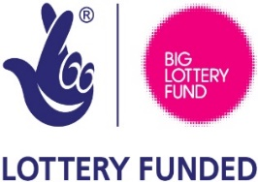
incredABLE Enterprises aims to (a) target young people who currently have no meaningful day time occupation, (b) provide trainees with work focused experience in a social enterprise environment, (c) involve trainees in all aspects of daily operations from design, product development, production, marketing and sales and (d) prepare young people for further work-based training by building confidence and self-esteem through the development of transferable job skills. Please note an interview may be required as part of the application process.

Admission Criteria: incredABLE Enterprises
Age: Are you aged between 18 – 28 years?
Location: Do you live within the Southern Health and Social Care Trust area?
Motivation: Do you want to learn new skills by developing new products and services as part of a busy team in a structured work environment?
Travel: The incredABLE Enterprises base is currently located at the Jethro Centre, 6 Flush Place, Lurgan, Craigavon, BT66 7DT. You MUST be able to access transport/support to help you to get to and from this venue.
Support: There are a total of 8 places available per year. The group of trainees will be supported throughout the day by 1 staff member (We are incredABLE project worker) as well as at least one volunteer.
Cost: The “We are incredABLE” project is a Big Lottery Funded project. Enterprise training and general activity costs are covered within this budget. Participants will need to arrange their transport and will require a pack lunch/snacks/drinks for during the day.
Time: Participants must be available ONE DAY PER WEEK from 10.00 – 3.00pm (Currently operating on Tuesday and Thursdays). The placement will last for two years at no cost to trainee.
Please note in the likely event of over subscription selection/eligibility criteria will be applied. Applicants will have the opportunity to reapply at any time and all eligible candidate’s details will be kept of file so that they can be notified of programme opportunities as they arise.

