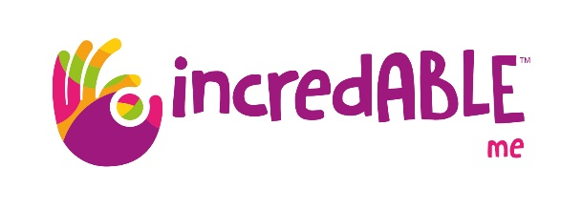
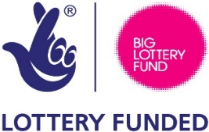

incredABLE Me aims to (a) target young people who are considering progressing to independent living environments in the future, (b) provide participants with daily life skills in a “home mirrored” environment and (c) improve participants understanding of overall health and wellbeing leading to greater confidence and a more active role within the family unit.
Admission Criteria: incredABLE Me
Age: Are you aged between 18 – 28 years?
Location: Do you live within the Southern Health and Social Care Trust Area?
Motivation: Do you want to live independently or perhaps take on a more active role in your home? Would you like to feel more confident in preparing a healthy meal, going shopping, doing exercise, managing your money, time or relationships?
Travel: The incredABLE Me programme will be facilitated at the Old School House property, 33 Drumbeebeg Road, Co Armagh, BT60 1HR. Transport may be provided as part of this programme (depending on individuals locations and proximity to central pick up point).
Support: There are a maximum number of 12 places per programme cycle (16 weeks) with 2-3 programmes running annually. The group of participants will be supported throughout the day by 1 staff member (We are incredABLE project worker) as well as a minimum of one volunteer.
Cost: The “We are incredABLE” project is a Big Lottery Funded project. The independent daily Living skills programme and general activity costs are covered within this budget. Participants will need to arrange transport (to school house or Pick Up point) and will require a pack lunch/snacks/drinks for during the day.
Time: Participants must be available ONE DAY PER WEEK from 10.00am – 3.00pm. (Usually a Wednesday) Participants are expected to complete the full course programme cycle.
*Please note in the event of over subscription applicants will have the opportunity to reapply for the next programme cycle with applicant’s details being kept on file for future correspondence throughout project life cycle.

